**Lab Exercise 2 Total: 100pts**

**Deadline: March 17, 2023 (during lab class)**

**Conditional Statements**

**Tasks:**

1. Write a program that asks the user to input a month (1-12) and prints the number of days in that month using switch statements.
2. Write a program that asks the user to input three integers and finds the maximum of the three using nested if-else statements.
3. Write a program that asks the user to input a number and checks if it's even or odd using the conditional operator.
4. Write a program that asks the user to input their weight in kilograms and their height in meters and calculates their body mass index (BMI) using the conditional operator. Then, it should print a message based on their BMI (e.g., "You are underweight" or "You are obese").

*Formula for BMI:* ***(weight in kg.) / (height in meters)2****­*

1. Write a program that asks the user to input his/her grade (out of 100). Using if-else statements, determine the grade point equivalence of the user’s grade.

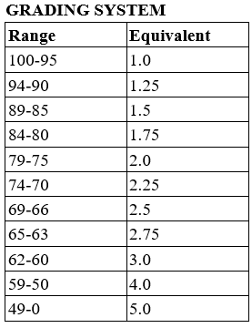

**Evaluation:**

* Each item is worth 20 pts.
  + Working code: 15 pts
  + Code organization and readability: 5 pts
    - Deductions:
      * Major mistake: 5pts
      * Minor mistake: 1pt
* Make sure to submit on or before the deadline. Submissions beyond the deadline will receive a 2pt deduction every 24hrs after the given deadline.